
Touchstones Project
Netcards

Generosity Netcards with Text

Abundance HRJ
Attention HRJ
Buddha HRJ
Casserole HRJ

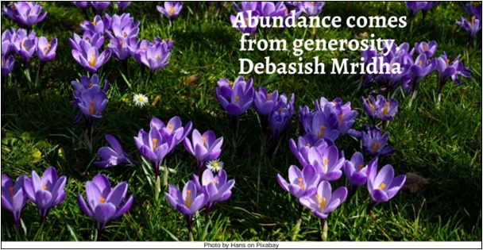

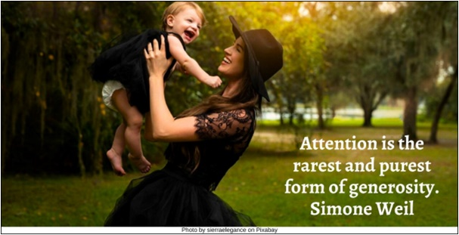



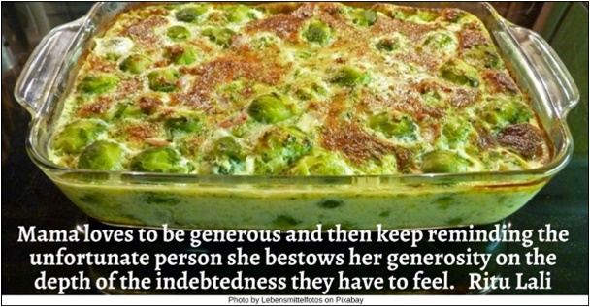

Charity HRJ
Cooking HRJ
Difficult HRJ
Earth HRJ

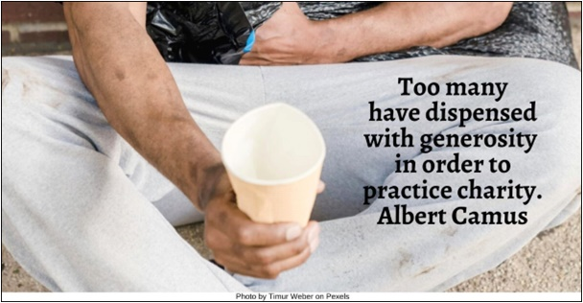

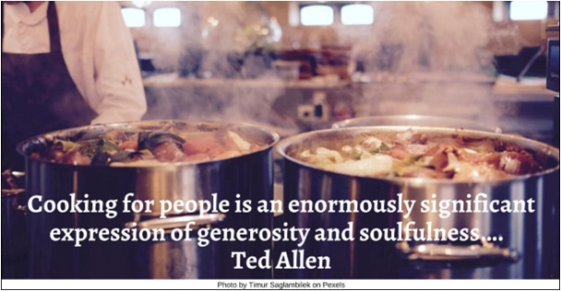

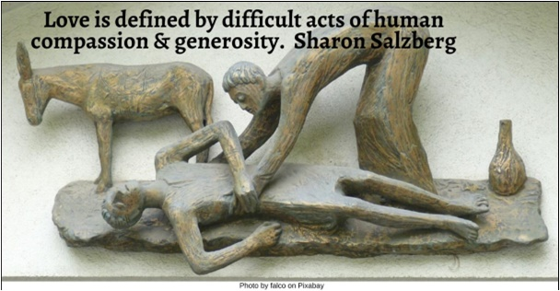

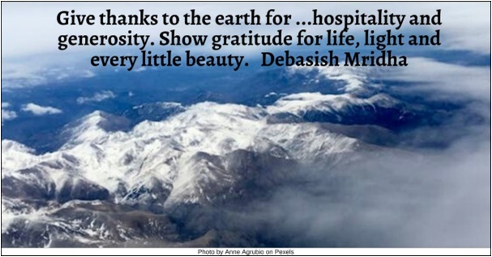

Giving HRJ
Ground HRJ
Heart HRJ
Life HRJ

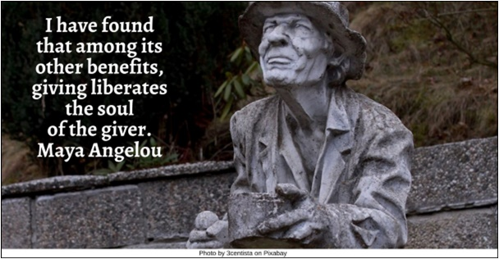

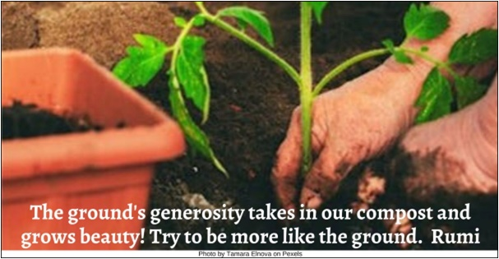

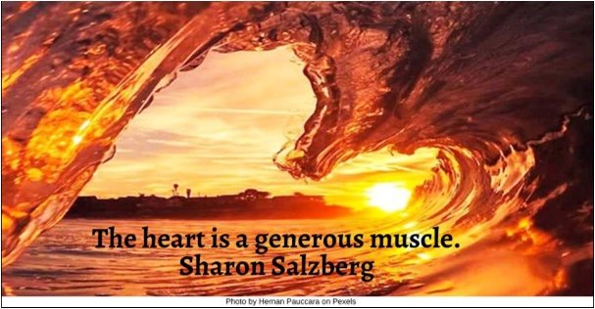

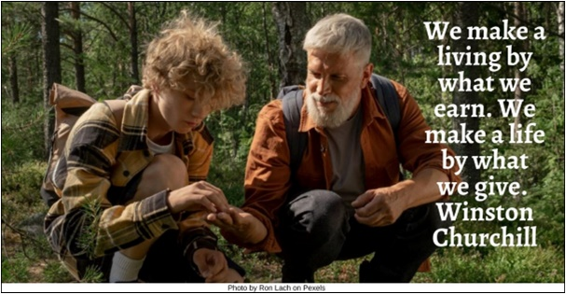

Love in Action HRJ
Mandela HRJ
Open Hand HRJ
Outrageously Kind HRJ

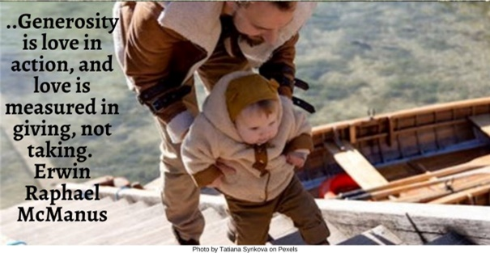

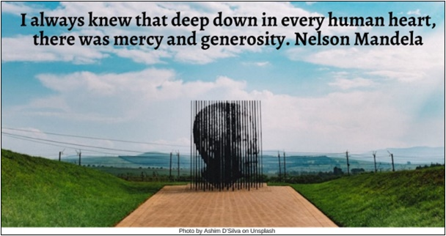

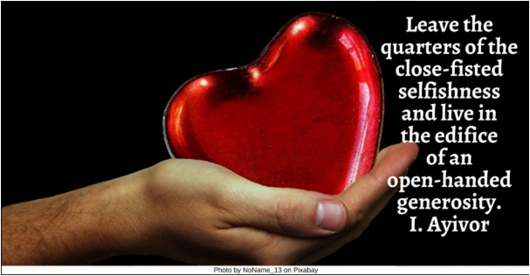



Planting HRJ
River HRJ
Sea HRJ
Selfish HRJ

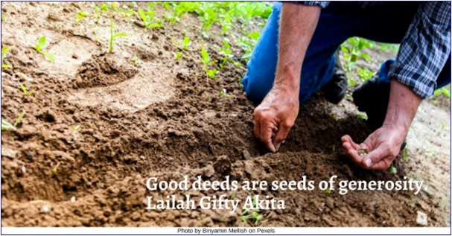

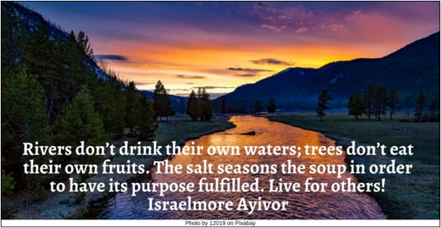

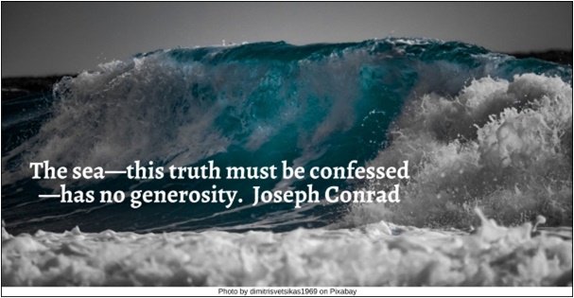

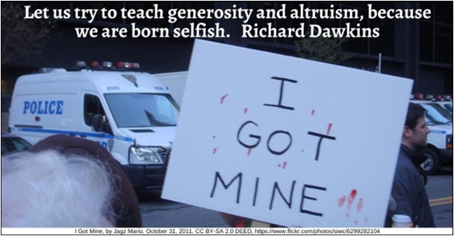

Sharing HRJ
Soul HRJ
Space to Be HRJ
Stop HRJ

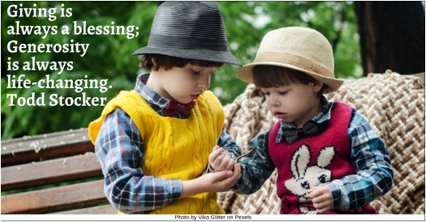

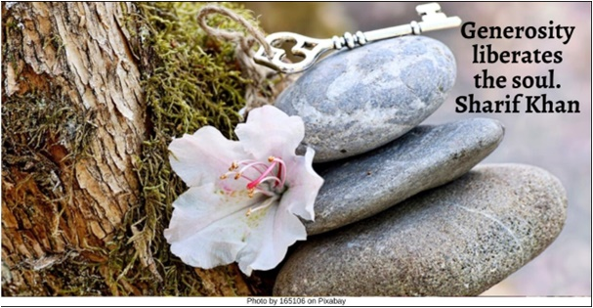

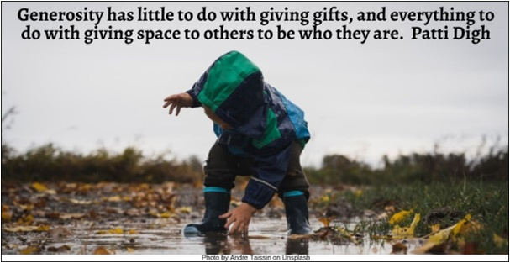



Strength HRJ
Taxes HRJ
The Thinker HRJ
Three Things HRJ

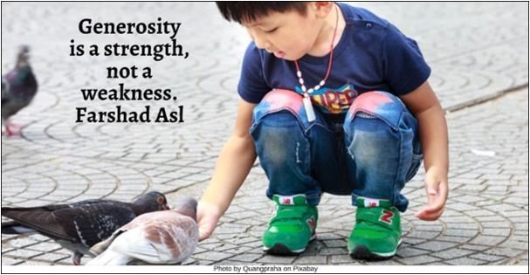





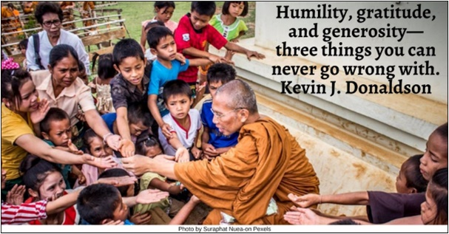

Violin HRJ
Walking
Web

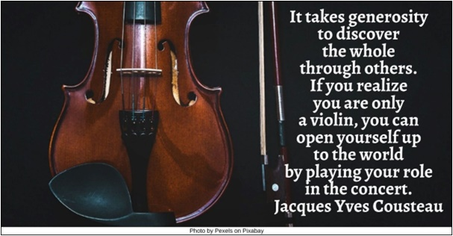



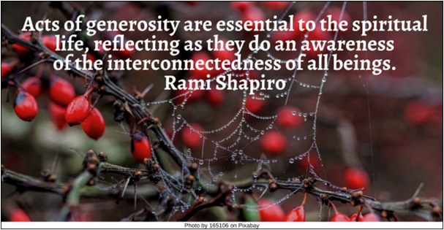

Text of Quotes
Abundance HRJ
Abundance comes from generosity. Debasish Mridha

Attention HRJ
Attention is the rarest and purest form of generosity. Simone Weil

Buddha HRJ
Even Karma rewards generosity. The good that you do must surely catch up with you! Chinonye J. Chidolue

Casserole HRJ
Mama loves to be generous and then keep reminding the unfortunate person she bestows her generosity on the depth of the indebtedness they have to feel. Ritu Lalit

Charity HRJ
Too many have dispensed with generosity in order to practice charity. Albert Camus

Cooking HRJ
Cooking for people is an enormously significant expression of generosity and soulfulness…. Ted Allen

Difficult HRJ
Love is defined by difficult acts of human compassion & generosity. Sharon Salzberg

Earth HRJ
Give thanks to the earth for the hospitality and generosity. Show gratitude for life, light and every little beauty. Debasish Mridha

Giving HRJ
I have found that among its other benefits, giving liberates the soul of the giver. Maya Angelou

Ground HRJ
The ground's generosity takes in our compost and grows beauty! Try to be more like the ground. Rumi

Heart HRJ
The heart is a generous muscle. Sharon Salzberg

Life HRJ
We make a living by what we earn. We make a life by what we give. Winston Churchill

Love in Action HRJ
...Generosity is love in action, and love is measured in giving, not taking. Erwin Raphael McManus

Mandela HRJ
I always knew that deep down in every human heart, there was mercy and generosity. Nelson Mandela

Open Hand HRJ
Leave the quarters of the close-fisted selfishness and live in the edifice of an open-handed generosity. Israelmore Ayivor

Outrageously Kind HRJ
Today, give yourself permission to be outrageously kind, irrationally warm, improbably generous. I promise it will be a blast. Sasha Dicter

Planting HRJ
Good deeds are seeds of generosity. Lailah Gifty Akita
Photo by Binyamin Mellish on Pexels

River HRJ
Rivers don’t drink their own waters; trees don’t eat their own fruits. The salt seasons the soup in order to have its purpose fulfilled. Live for others! Israelmore Ayivor
Sea HRJ
The sea—this truth must be confessed—has no generosity. Joseph Conrad

Selfish HRJ
Let us try to teach generosity and altruism, because we are born selfish. Richard Dawkins

Sharing HRJ
Giving is always a blessing; Generosity is always life-changing. Todd Stocker

Soul HRJ
Generosity liberates the soul. Sharif Khan

Space to Be HRJ
Generosity has little to do with giving gifts, and everything to do with giving space to others to be who they are. Patti Digh

Stop HRJ
When it comes to giving, some people stop at nothing. Vernon McLellan

Strength HRJ
Generosity is a strength, not a weakness. Farshad Asl

Taxes HRJ
Generosity is not always tax deductible. Ken Solts

The Thinker HRJ
Of the various kinds of intelligence, generosity is the first. John Surowiecki

Three Things HRJ
Humility, gratitude, and generosity—three things you can never go wrong with. Kevin J. Donaldson

iolin HRJ
It takes generosity to discover the whole through others. If you realize you are only a violin, you can open yourself up to the world by playing your role in the concert. Jacques Yves Cousteau

Walking
Every time I take a step in the direction of generosity, I know that I am moving from fear to love. Henri J.M. Nouwen

Web
Acts of generosity are essential to the spiritual life, reflecting as they do an awareness of the interconnectedness of all beings. Rami Shapiro

